The El Nino Dataset:
The folder RealApplication that stores the El Nino data set applied in the Real Application section of the manuscript, including the actual observations (ElNino_ERSST.csv), corresponding timestamps for observations (ElNino_ERSST_tpts.csv) and custom classification labels (ElNino_ERSST_label.csv).

The El Niño dataset is a well-known climate time-series dataset commonly used in time-series forecasting, anomaly detection, and regression modeling.
It contains oceanic and atmospheric measurements recorded over time in the tropical Pacific, measurements that help describe and predict El Niño / La Niña events.
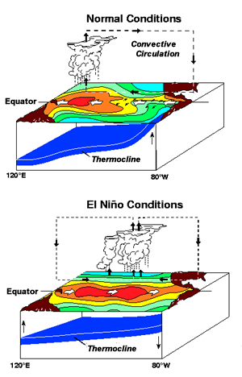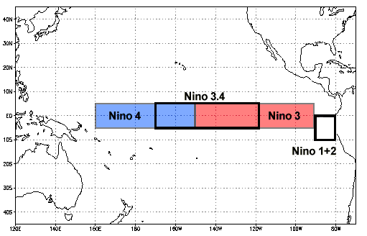

The “ElNino_ERSST” CSV part is the main data. The dataset typically includes monthly measurements. While variations exist depending on preprocessing, the layout you show is consistent with common El Niño benchmark datasets.
Each of these 12 columns in the CVS file, represents a month of the year for a given year’s sequence. Also, we have 277 rows or observations.
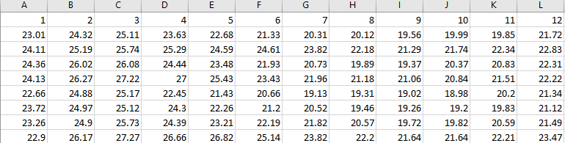
These values are usually SST anomalies, which means: Sea Surface Temperature (SST) Anomalies
- Temperature difference from long-term average
- Measured in °C
- Positive values → warmer than normal (El Niño–like)
- Negative values → cooler than normal (La Niña–like)
The dataset records these SST anomalies for a specific region, usually Niño 3, Niño 3.4, or Niño 4, depending on the version.

What the Goal of the Dataset Is?

1. Time-Series Forecasting: Predict future SST anomalies (Predict next month from previous months, Predict next year from past years, Predict onset of El Niño/La Niña). Example: “Given the last 12 months of SST anomalies, what will next month be?”

2. El Niño / La Niña Classification: Convert the continuous values into categories (El Niño, Neutral, La Niña) based on thresholds.

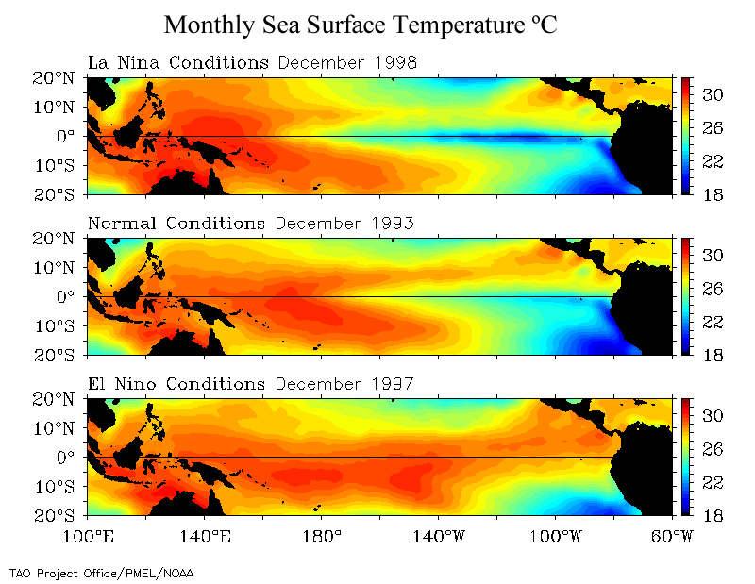

3. Anomaly Detection: Detect when SST anomalies depart from the normal range.

Implementing Regular FAE on El Niño dataset:
Now using Read_ElNino_Data.py file, we can read the data.

